DATA ANALYTICS AND VISUALIZATION
2. Regression Models
2.1 Introduction to simple Linear Regression: The Regression Equation, Fitted value and Residuals, Least Square Introduction to Multiple Linear Regression: Assessing the Model, Cross-Validation, Model Selection and Stepwise Regression, Prediction Using Regression
2.2 Logistic Regression: Logistic Response function and logit, Logistic Regression and GLM, Generalized Linear model, Predicted values from Logistic Regression, Interpreting the coefficients and odds ratios, Linear and Logistic Regression: similarities and Differences, Assessing the models.
PAST QUESTIONS:
- What is regression? What is simple linear regression? (M23)
- Describe how logistic regression can be used as a classifier. (M23)
- Evaluating the Residuals in Linear Regression. (M23)
- The regression lines of a sample are x+6y=6 and 3x+2y=10. (D23)
Find (i) sample means x bar and y bar.
(ii) coefficient of correlation between x and y.
- Differentiate between linear regression and logistic regression. (D23, D24)
- Find two lines of regression from the following data: (D23)
Age of Husband | 25 | 22 | 28 | 26 | 35 | 20 | 22 | 40 | 20 | 18
Age of wife | 18 | 15 | 20 | 17 | 22 | 14 | 16 | 21 | 15 | 14
Estimate (i) the age of husband when the age of wife is 19 and (ii) the age of wife when the age of the husband is 30.
- Fit a regression equation to estimate Beta 0, Beta 1 and Beta 3 to the following data of a transport company on the weights of 6 shipments, the distances they were moved and the damage of the goods that was incurred. (D23)
Weight X1 (1000 kg) | 4.0 | 3.0 | 1.6 | 1.2 | 3.4 | 4.8
Distance X2 (100 km) | 1.5 | 2.2 | 1.0 | 2.0 | 0.8 | 1.6
Damage Y (Rs.) | 160 | 112 | 69 | 90 | 123 | 186
Estimate the damage when a shipment of 3700 kg is moved to a distance of 260 km.
- From the following results, obtain two regression equations and estimate the yield when the rainfall is 29 cm and the rainfall when the yield is 600 kg. (D23)
 | Yield in Kg. | Rainfall in cm.
Mean | 508.4 | 26.7
SD | 36.8 | 4.6
Coefficient of correlation | 0.52
- What is stepwise regression? State and explain different types of stepwise regression. (D23)
- Regression plot. (D23)
- Generalized linear model (GLM). (D23)
- What is Stepwise regression? Explain its types. (M24)
- The number of bacterial cells (y) per unit volume in a culture at different hours (x) is given below: (M24)
X | 0 | 1 | 2 | 3 | 4 | 5 | 6 | 7 | 8 | 9
Y | 43 | 46 | 82 | 98 | 123 | 167 | 199 | 213 | 245 | 272
Fit lines of regression of y on x and x on y. Also, estimate the number of bacterial cells after 15 hours.
- What is Logistic Regression? What are the similarities and differences between linear regression and logistic regression? (M24)
- Calculating the regression equation of x on y and y on x form the following data and estimate x when y = 20. Also determine the value of correlation coefficient. (D24)
x | 10 | 12 | 13 | 17 | 18
y | 5 | 6 | 7 | 9 | 13

NOTES:

*Regression :-
Regression is a statistical technique in data analytics used to identify relationships between dependent and independent variables. It helps predict continuous numerical outcomes based on input data. In visualization, regression is often represented using trend lines, scatter plots, and residual plots to understand data patterns and model performance.

*Linear Regression :-
Linear regression is a statistical method used to model the relationship between a dependent variable and one or more independent variables. It provides valuable insights for prediction and data analysis.

* Simple Linear Regression :-
Simple Linear Regression (SLR) is a statistical method used to model the relationship between a single independent variable (X) and a dependent variable (Y) by fitting a straight line to the data. It is commonly used to predict outcomes and identify trends.
The variable which is the base of prediction is called as independent variable and the variable which is to be predicted is called as dependent variable.
Equation of Simple Linear Regression:
y= β0​+ β1​X
where: Y is the dependent variable
X is the independent variable
β0 is the intercept
β1 is the slope

*Multiple Linear Regression :-
Multiple linear regression involves more than one independent variable and one dependent variable.
The equation for multiple linear regression is:
y=β0+β1X1+β2X2+………βnXn
where: Y is the dependent variable
X1, X2, …, Xn are the independent variables
β0 is the intercept
β1, β2, …, βn are the slopes

*Stepwise Regression :-
Stepwise regression is a method of fitting a regression model by iteratively adding or removing variables. It is used to build a model that is accurate and parsimonious, meaning that it has the smallest number of variables that can explain the data.
There are two main types of stepwise regression:
- Forward Selection – In forward selection, the algorithm starts with an empty model and iteratively adds variables to the model until no further improvement is made.
- Backward Elimination – In backward elimination, the algorithm starts with a model that includes all variables and iteratively removes variables until no further improvement is made.

*Regression Plot :-
A regression plot is a graphical representation of the relationship between an independent variable (predictor) and a dependent variable (target) using a regression line. It helps in understanding trends, patterns, and the goodness of fit of a regression model.
Purpose of a Regression Plot:
- To visualize the relationship between variables.
- To check the strength and direction of the relationship.
- To identify outliers and deviations from linearity.
- To assess model accuracy.

*Logistic Regression :-
Logistic regression is a supervised machine learning algorithm used for classification tasks where the goal is to predict the probability that an instance belongs to a given class or not. Logistic regression is a statistical algorithm which analyze the relationship between two data factors.
Types of Logistic Regression -
- Binomial: In binomial Logistic regression, there can be only two possible types of the dependent variables, such as 0 or 1, Pass or Fail, etc.
- Multinomial Logistic Regression: Used when there are more than two categories without ordering (e.g., cat, dog, bird).
- Ordinal Logistic Regression: Used when there are more than two categories with a natural order (e.g., low, medium, high).
*Difference between Linear and Logistic Regression :-
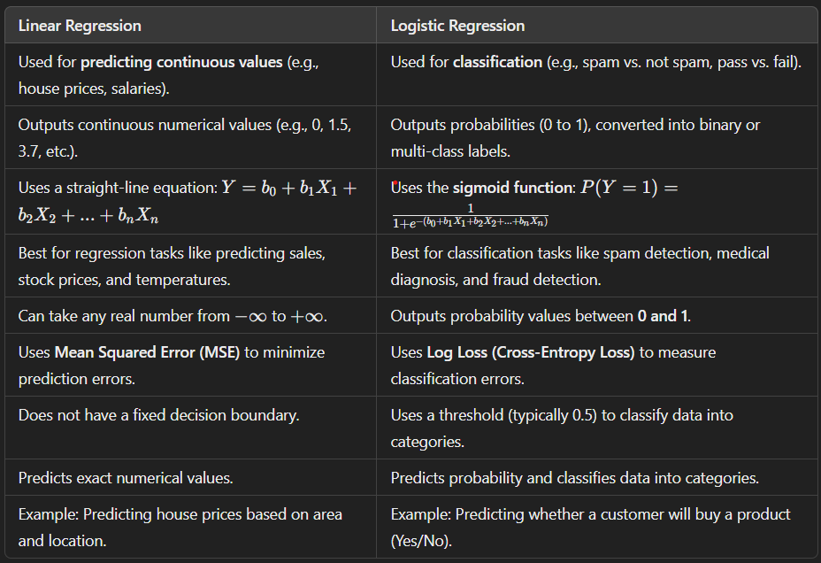
*Generalized Linear Model :-
GLMs (Generalized linear models) are a type of statistical model that is extensively used in the analysis of non-normal data, such as count data or binary data. They enable us to describe the connection between one or more predictor variables and a response variable in a flexible manner.
A Generalized Linear Model (GLM) is an extension of traditional linear regression that allows for the dependent variable (target) to follow any distribution from the Exponential Family of distributions (e.g., Normal, Poisson, Binomial). Unlike traditional linear regression models, which assume a linear relationship between the response and predictor variables, GLMs allow for more flexible, non-linear relationships by using a different underlying statistical distribution.
Advantages of GLMs:
- Flexibility: Can handle a wide range of data types and distributions.
- Versatility: Suitable for continuous, binary, count, and other types of outcomes.
- Interpretability: The coefficients in GLMs can be interpreted similarly to linear regression models, providing insights into relationships between variables.
Disadvantages of GLMs:
- Complexity increases.
- Overfitting: With flexible models, there is a risk of overfitting if the model is too complex or not properly regularized.
- Computationally Intensive: GLMs with complex distributions may require more computational power and time to fit.

